The Magazine Cover

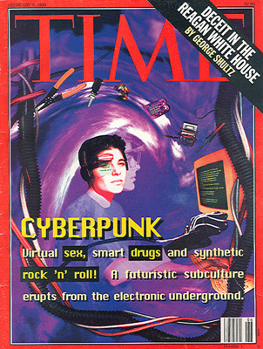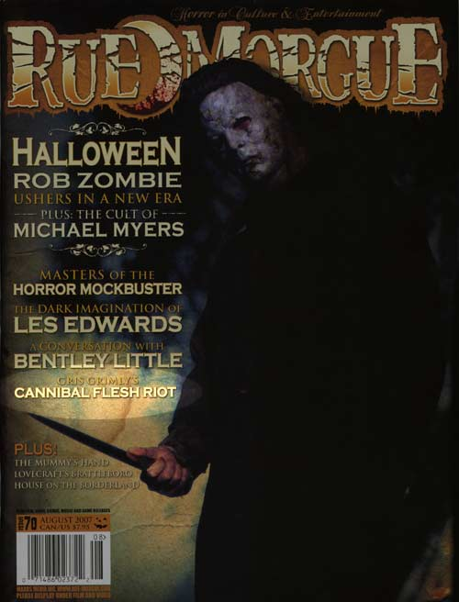

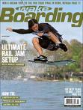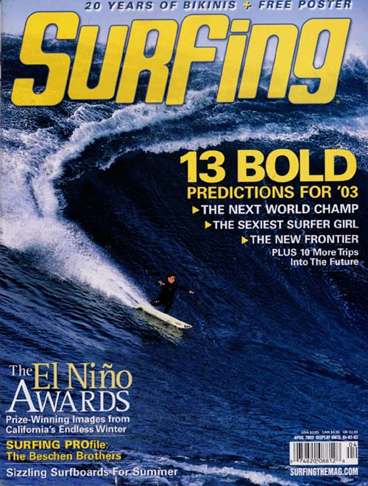

TASK: Create a magazine cover using Photoshop:

Structure : Most magazine covers include

A Masthead that contains non- changing features such as the magazines title and price
A logo
A motif that identifies the theme, such as the platypus peeping out from the Australian Geographic Title
A Photograph / drawings advertising specific features
Subheadings which preview some of the feature stories
Bold or highlighted announcements of competitions and quizzes, posters maps and lift out sections

Language Features
A short sharp title that is easy to remember,
A short statement of the magazines main theme- placed directly underneath the title
Catchy headlines
Questions to confront and involve the reader
Rhyme – such as Beckham id reckon

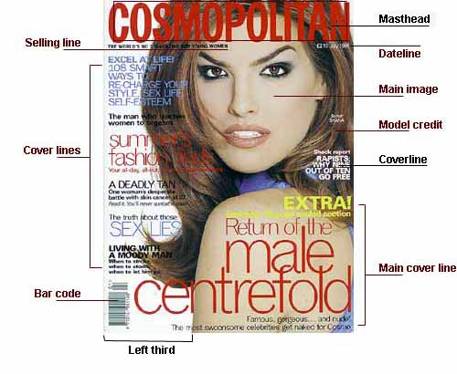
A good cover needs to accomplish four things:
1. Identify the personality of the magazine.
2. Attract the target audience
3. Lure the reader into the magazine
4. Establish a visual identity (consistent use of format)

To begin
Open Photoshop
Create New file - My magazine cover -
For this exercise we will set our photoshop document at A3 size
Height 42 cm Width 29 cm- Resolution – 300 DPI / RGB colour

Remember to work in separate layers for the various elements on the cover page

Masthead- - Dateline -Photo – Main Cover line - Sub coverlines - Bar code

Your magazine cover will assessed on whether you included the above elements and how you carry out unity in your magazine cover.

Unity can be achieved by carrying out a common theme in the type styles, photos, story titles and descriptions. Do all the parts work together?

Think about readability, can you read the type against the background?
Is the type style readable?
Are the sentences too long?
Are the titles descriptive enough to make you know what the article is about? Does the type size signify the importance?

Does the photo or photos support the theme?
Does the photo catch your eye? Is it too busy or too simple?

How is your effort and craftsmanship?
You will need to be selecting, cutting, pasting and cropping.
Does your cover look professionally neat?

Layout, how did you arrange all the elements?
Is the type all lined up flush left, right, centered?
Is the type over the picture or a background?
Did you add a banner with the issue date, web site, and cost?
Does the layout make it easy to read or confusing?

Notes on Photoshop Tools- detail notes and tutorial can be found in the year 11 unit one folder PDF file

The Toolbox

You select a variety of tools from the Toolbox by clicking on the icons. Within each type of tool you can select "hidden" tools by dragging the tool to the side or by pressing on the icon until the hidden options drop to the side. See examples below.

To view the Toolbox Go to Window > Show Tools..

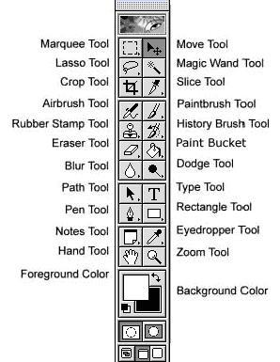

Rectangular/Elliptical Marquee Tool
Use this to create a rectangular or elliptical selection. If you want a perfect square or rectangle, hold down the shift key as you drag out the marquee.

Eraser Tool
This simply deletes the image where you paint, leaving the current background colour behind or, if you’re working on an image layer, making that part of the image layer transparent.

Move Tool
You use this to move layers around in multi-layered images, or to drag one image (from its own window) on to another to add it as a new layer. It can also be used for moving selected image areas from one place to another.

Background Eraser Tool
Try this if you’re trying to trace around an object’s outline. The tool preserves the colours under the brush (the object outline) but erases dissimilar colours (the background).

Lasso Tool
With this you can draw a freehand outline (lasso) around an area in the image to select it for editing. It’s not the ideal tool, though, because you need a steady hand and you have to start again if you make an error

Gradient Tool
You can use one of Photoshop’s preset gradients or choose your own by selecting appropriate foreground and background colours. You simply drag across the image to produce a gradient along the axis of the mouse movement.

Polygonal Lasso Tool
A more useful variant of the Lasso tool. Here you click the mouse button to add straight-line segments to a selection as you go along. It’s much more accurate than the freehand lasso, though slower.

Blur Tool
Used for localised blurring, though of limited benefit when applied directly to images. It can be useful, though, when you’re working with layer masks, which may have sharp edges that need softening.

Magic Wand Tool
With this you can click on any area of an image to select both it and areas of similar tone. You set the ‘tolerance’ of the tool on the Options bar. Higher tolerances mean a greater range of tones will be selected.

Sharpen Tool
Use this to apply a localised sharpening effect. It’s cumulative, so you can build it up to the required degree. It can be useful after cloning operations, which can sometimes lead to slightly blurred detail.

Crop Tool
Use this to mark out the area of the image you want to keep, then double-click inside it to delete the rest. You can also type in dimensions and resolution values in the Options bar to crop the image to a specific size.

Dodge Tool
The equivalent of ‘dodging’ in the old black and white darkroom, where parts of the print are held back to make them lighter than the rest. Try a low opacity setting and slowly build up the lightening effect.

Spot Healing Brush Tool
New to CS2, this is like the Healing Brush Tool in that it replaces blemishes with nearby pixels. Here, though, you don’t need to choose the source for the replacement pixels – they’re chosen automatically.

Burn Tool
The opposite of dodging. Here, you’re ‘burning in’ or darkening selected areas of the image. Note, though, that with many digital cameras, highlight detail may be already be burned out and lost forever.

Patch Tool
With this you can select larger blemishes – scratches, for example – then drag the selection shape on to a nearby area that’s undamaged. Photoshop will blend the repair seamlessly. It works best on even-toned areas like skies.

Sponge Tool
This has no real equivalent in the darkroom. You can set it (via the Options bar) to add or reduce saturation. In ‘desaturate’ mode it’s useful for removing colour fringing from digital camera images.

Brush Tool
This is used by artists when painting on a blank canvas in Photoshop, but photographers might also use it on layer masks to blend image layers more effectively, or for applying other subtle image repairs.

Eyedropper Tool Use this to click on any area of the image – this loads the colour you clicked on as the foreground colour. You’ll see the eyedropper in many other dialogs – in each case, it’s used for pinpointing specific colours.

Clone Stamp Tool
This is the same as the ‘Clone’ tool in other image editors. You start by setting the ‘source’ – the area of the image you want to copy – then click or drag to ‘clone’ this source area on to a different part of the image.

Hand Tool
When you’re zoomed in on an image so that you can’t see all of it at once, use the Hand Tool to drag it around within the window. Alternatively, hold down the Spacebar to switch to the Hand Tool at any time.

History Brush
In Photoshop’s History palette you can create ‘Snapshots’, recording the image state at any stage. Using the History Brush, you can ‘paint’ previous image states (Snapshots) over parts of the current image

Zoom Tool
With this selected, you click on the image to zoom in and alt-click to zoom out. The Options bar displays two useful buttons too – Actual Pixels and Fit Screen.
Use this to create a rectangular or elliptical selection. If you want a perfect square or rectangle, hold down the shift key as you drag out the marquee.

Eraser Tool
This simply deletes the image where you paint, leaving the current background colour behind or, if you’re working on an image layer, making that part of the image layer transparent.

Move Tool
You use this to move layers around in multi-layered images, or to drag one image (from its own window) on to another to add it as a new layer. It can also be used for moving selected image areas from one place to another.

Background Eraser Tool
Try this if you’re trying to trace around an object’s outline. The tool preserves the colours under the brush (the object outline) but erases dissimilar colours (the background).

Lasso Tool
With this you can draw a freehand outline (lasso) around an area in the image to select it for editing. It’s not the ideal tool, though, because you need a steady hand and you have to start again if you make an error.

Gradient Tool
You can use one of Photoshop’s preset gradients or choose your own by selecting appropriate foreground and background colours. You simply drag across the image to produce a gradient along the axis of the mouse movement.

Polygonal Lasso Tool
A more useful variant of the Lasso tool. Here you click the mouse button to add straight-line segments to a selection as you go along. It’s much more accurate than the freehand lasso, though slower.

Blur Tool
Used for localised blurring, though of limited benefit when applied directly to images. It can be useful, though, when you’re working with layer masks, which may have sharp edges that need softening.

Magic Wand Tool
With this you can click on any area of an image to select both it and areas of similar tone. You set the ‘tolerance’ of the tool on the Options bar. Higher tolerances mean a greater range of tones will be selected.

Sharpen Tool
Use this to apply a localised sharpening effect. It’s cumulative, so you can build it up to the required degree. It can be useful after cloning operations, which can sometimes lead to slightly blurred detail.

Crop Tool
Use this to mark out the area of the image you want to keep, then double-click inside it to delete the rest. You can also type in dimensions and resolution values in the Options bar to crop the image to a specific size.

Dodge Tool
The equivalent of ‘dodging’ in the old black and white darkroom, where parts of the print are held back to make them lighter than the rest. Try a low opacity setting and slowly build up the lightening effect.

Spot Healing Brush Tool
New to CS2, this is like the Healing Brush Tool in that it replaces blemishes with nearby pixels. Here, though, you don’t need to choose the source for the replacement pixels – they’re chosen automatically.

Burn Tool
The opposite of dodging. Here, you’re ‘burning in’ or darkening selected areas of the image. Note, though, that with many digital cameras, highlight detail may be already be burned out and lost forever.

Patch Tool
With this you can select larger blemishes – scratches, for example – then drag the selection shape on to a nearby area that’s undamaged. Photoshop will blend the repair seamlessly. It works best on even-toned areas like skies.

Sponge Tool
This has no real equivalent in the darkroom. You can set it (via the Options bar) to add or reduce saturation. In ‘desaturate’ mode it’s useful for removing colour fringing from digital camera images.

Brush Tool
This is used by artists when painting on a blank canvas in Photoshop, but photographers might also use it on layer masks to blend image layers more effectively, or for applying other subtle image repairs.

Eyedropper Tool Use this to click on any area of the image – this loads the colour you clicked on as the foreground colour. You’ll see the eyedropper in many other dialogs – in each case, it’s used for pinpointing specific colours.

Clone Stamp Tool
This is the same as the ‘Clone’ tool in other image editors. You start by setting the ‘source’ – the area of the image you want to copy – then click or drag to ‘clone’ this source area on to a different part of the image.

Hand Tool
When you’re zoomed in on an image so that you can’t see all of it at once, use the Hand Tool to drag it around within the window. Alternatively, hold down the Spacebar to switch to the Hand Tool at any time.

History Brush
In Photoshop’s History palette you can create ‘Snapshots’, recording the image state at any stage. Using the History Brush, you can ‘paint’ previous image states (Snapshots) over parts of the current image

Zoom Tool
With this selected, you click on the image to zoom in and alt-click to zoom out. The Options bar displays two useful buttons too – Actual Pixels and Fit Screen.

